LAB # 3
Introduction to Concurrency
OBJECTIVE
Understanding and implementing the concept of concurrency through different mechanisms of multithreading.
Lab Task:
- Implement the following program on eclipse IDE and answer the following questions:
- How many threads running? 4 (1 main+ 3 user-defined)
- How many tasks are running? 3
- If more tasks are added than what will be the impact on number of threads? More threads → higher CPU load and context switching.
- Explain the flow of program:
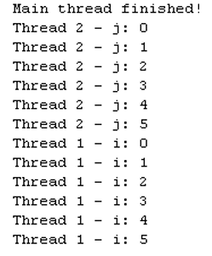

- With the help of threading print two tables concurrently, print one table number of student roll number e.g. 2019-SE-092 and second number should be date of birth e.g. 05-April.
